**COMSATS University Islamabad, Abbottabad Campus**

**Department of Computer Science**

**Project Proposal**

**UNIVERSITY TIMETABLE GENERATION SYSTEM**

**CSC392 Object Oriented Software Engineering**

Submitted on: <3/April/2023 >

Group Members:

BASIT IQBAL (FA21-BSE-050)

Fatima Aftab (FA21-BSE-088)

Essa Masood (FA21-BSE-086)

Ebadat Nissa (FA21-BSE-085)

Ahmed Tariq (FA21-BSE-048)

Waleed Rashid (FA21-BSE-162)

Table of Contents

CHAPTER 1 PROJECT PROPOSAL 7

Introduction 7

Vision and Business Case 7

Use-Case Model 8

1. Functional Requirements: 8

Supplementary Specification 8

Glossary 10

Risk List & Risk Management Plan 10

Risk List: 10

1. Data loss due to system failure or user error. 10

2. Inadequate system security leading to unauthorized access or data breaches. 10

3. Incorrect data input by users. 10

4. Insufficient capacity to handle large volumes of data. 10

5. Software bugs or errors leading to system crashes or malfunctions. 10

6. Inability to handle unexpected changes in scheduling or events. 10

7. Resistance from users to adopt the new system or change their habits. 10

8. Lack of resources (time, budget, personnel) to implement or maintain the system. 10

9. Lack of integration with other systems, such as student information systems or other systems. 10

Risk Management Plan: 10

1. Regular backups and disaster recovery procedures should be implemented to mitigate the risk of data loss. 10

2. Access controls, firewalls, and encryption should be used to ensure system security and protect against unauthorized access or data breaches. 10

3. Data validation rules and error-checking mechanisms should be implemented to prevent incorrect data input by users. 10

4. The system should be designed to handle anticipated volumes of data and scalable to accommodate future growth. 10

5. Software testing and quality assurance processes should be in place to identify and fix bugs and errors before they cause significant problems. 10

6. The system should be flexible and adaptable to handle unexpected changes in scheduling or events. 10

7. User training and communication should be conducted to encourage user adoption and facilitate the transition to the new system. 10

8. Adequate resources should be allocated to implement and maintain the system. 10

CHAPTER 2 USE CASES 11

2.1 Use Case Diagram 11

2.2 Use Cases Distribution 12

2.3 Brief Level Use Cases 13

Eissa Masood (FA21-BSE-086) 13

Use Case: Allocate Courses 13

Eissa Masood (FA21-BSE-086) 13

Use Case: Select Teacher 13

Ebadat Nissa Khan (FA21-BSE-085) 13

Use Case: View time table 13

Ebadat Nissa Khan (FA21-BSE-085) 13

Use Case: View time student table 13

Ebadat Nissa Khan (FA21-BSE-085) 14

Use Case: View teacher time table 14

Ahmed Tariq (FA21-BSE-048) 14

Use Case: Set semester courses. 14

In a timetable management system, set semester courses are the courses that are offered during a specific semester or academic term. These courses can be categorized based on various factors such as course code, course name, level of difficulty, number of credits, and course prerequisites. 14

Set semester courses are important for a timetable management system as they form the basis for creating the class schedule for that semester. The system needs to ensure that all courses offered in a particular semester are scheduled in such a way that there are no conflicts in the course schedules. 14

To manage semester courses effectively, a timetable management system may use different techniques such as clustering courses based on similarity, grouping courses based on the availability of the required resources such as classrooms and lab equipment, and scheduling courses based on student demand and faculty availability. 14

By effectively managing set semester courses in a timetable management system, administrators can ensure that students are able to complete the required courses within the specified time frame and are able to graduate on time. Moreover, a well-managed course schedule can reduce scheduling conflicts, maximize the use of resources, and improve the overall efficiency of the academic program. 14

Ahmed Tariq (FA21-BSE-048) 15

Use Case: Set Criteria 15

Ahmed Tariq (FA21-BSE-048) 16

Use Case: Set Constrains 16

In a timetable management system, set constraints are used to ensure that the schedule meets certain conditions or requirements. These constraints can take various forms, including course availability, classroom availability, teacher availability, student availability, and room capacity. 16

Course availability constraints ensure that each course is scheduled during specific days and times. Classroom availability constraints ensure that each class is assigned to an available classroom. Teacher availability constraints ensure that each teacher is available to teach during the scheduled time slot. Student availability constraints ensure that each student can attend all their registered classes without conflicts. Room capacity constraints ensure that each class is assigned to a classroom with sufficient capacity. 16

By incorporating these and other set constraints, a timetable management system can generate a schedule that is efficient, effective, and meets the needs of all stakeholders involved, including students, teachers, and administrators. Set constraints help to prevent scheduling conflicts, ensure that resources are utilized effectively, and promote optimal learning outcomes for all students. 16

Waleed Rashid (FA21-BSE-162) 16

Use Case: Manage slots. 16

Fatima Aftab (FA21-BSE-088) 16

Use Case: Generate Timetable 16

Fatima Aftab (FA21-BSE-088) 16

Use Case: Modify Timetable 16

BASIT IQBAL (FA21-BSE-050) 17

Use Case: Login 17

BASIT IQBAL (FA21-BSE-050) 17

Use Case: Logout 17

2.4 Fully Dressed Use Cases 18

BASIT IQBAL (FA21-BSE-050) 18

Use Case UC1: Login 18

BASIT IQBAL (FA21-BSE-050) 19

Use Case UC2: Log out 19

Waleed Rashid(FA21-BSE-162) 21

Use Case UC1: Manage slots 21

Eissa Masood (FA21-BSE-086) 24

Use Case UC1: Allocate Course 24

Eissa Masood (FA21-BSE-086) 26

Use Case UC1: Select Teacher 26

Ahmed Tariq (FA21-BSE-048) 28

Use Case UC1: Manage slots 28

Ahmed Tariq (FA21-BSE-162) 30

Use Case UC1: Add courses 30

Ahmed Tariq (FA21-BSE-162) 33

Use Case UC1: Manage rooms 33

FATIMA AFTAB (FA21-BSE-088) 35

Use Case UC4: Generate Timetable 35

FATIMA AFTAB (FA21-BSE-088) 37

Use Case UC5: Modify timetable 37

WALEED RASHID (FA21-BSE-162) 40

Use Case UC5: Manage Slots 40

2.4 Prototypes 42

2.4.1. BasitIqbal 42

2.4.2. Fatima Aftab 43

Ebadat Nisa Khan- View timetable by student,View timetable by teacher.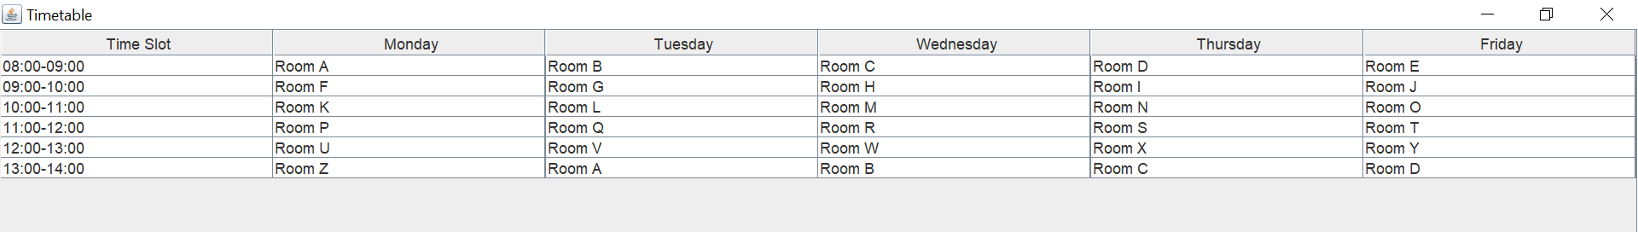 44

CHAPTER 3 DOMAIN MODEL 3.1 Individual Partial Domain Model 45

UC 1,2 : Login & Logout (BASIT IQBAL ,FA21-BSE-050) 45

UC 3,4 : Generate Timetable and Modify timetable (Fatima Aftab,Fa21-bse-088) 46

CHAPTER 4 System Sequence Diagram (SSD) 48

4.1. LOGIN (BASIT IQBAL : FA21-BSE-050) 48

4.2. Logout (BASIT IQBAL : FA21-BSE-050) 49

4.3. Generate Timetable Scenario (Fatima Aftab) 50

4.4. Modify Timetable Scenario (Fatima Aftab) 51

51

4.5. Manage Slots (Waleed Rashid) 52

# CHAPTER 1 PROJECT PROPOSAL

## Introduction

As we know, one of the major challenges faced by universities is creating a timetable that meets the needs of both students and faculty. The current system of manual timetable generation is time-consuming, error-prone, and often results in scheduling conflicts that are difficult to resolve.

The proposed system will be a desktop application that automates the timetable generation process. The system will take into consideration the constraints and requirements of both students and faculty, such as slots, professor availability, room availability. The system will also be customizable, allowing for the inclusion of specific course preferences and restrictions.

The benefits of this proposed system are numerous. Firstly, it will eliminate the need for manual timetable generation, reducing the potential for errors and inconsistencies. Secondly, it will increase the efficiency of the timetable generation process, freeing up valuable time for administrators to focus on other important tasks. Lastly, it will improve the student **experience** by providing them with a timetable that is tailored to their specific needs, ensuring that they have access to the classes they need at times that are convenient for them.

## Vision and Business Case

Vision

The main objective of the Timetable Management System is to manage the details of Timetable, Faculty, Subject, Student, Course. It manages all the information about Timetable, Semester, Course, Timetable. The project is totally built at administrative end and thus only the administrator is guaranteed access.

Business cases:

Cost savings: The implementation of a University Timetable Management System can save the university significant costs by automating the scheduling process and reducing the need for manual labor. By streamlining the scheduling process, the university can reduce administrative costs, increase operational efficiency, and allocate resources more effectively.

Improved student retention: A University Timetable Management System can contribute to improved student retention rates by providing students with an easy-to-use platform to view their schedules and adjust as needed. By giving students more control over their schedules, they are more likely to stay enrolled in courses and avoid conflicts that could lead to dropping out.

Enhanced student satisfaction: A University Timetable Management System can contribute to enhanced student satisfaction by providing them with a more user-friendly scheduling experience.

## Use-Case Model

## Functional Requirements:

* **Admin Requirements:**
* The only admin can select, remove, create, and update slot of timetable.
* The only admin can add, select, update, and remove rooms for timetable.
* The only admin can allocate courses to teachers to teach.
* The only admin can select courses and select teachers for semester.
* The only admin can view the timetable of both teachers and students.
* The only admin can request to system to generate timetable.
* **Teacher Requirements:**
* Teachers can only view their timetables.
* Teachers can give preferences for courses to be taught.
* **Student Requirements:**
* Students can only view their timetable.
* **System Requirements:**
* The University Timetable Generation System allows login and logout functionality to admins , students, and teachers.
* The University Timetable Generation System allows registration of new admins.
* The University Timetable Generation System generates timetables for admins, students, and teachers.
* The University Timetable Management System only accepts valid login details to enroll admins, students, and teachers in the system.

## Supplementary Specification

**Introduction:**

The Timetable Management System is an application used by universities to manage the scheduling and allocation of courses and teaching resources. This Supplementary Specification outlines additional features and requirements for the system.

**User Interface:**

The user interface should be user-friendly and easy to navigate, with clear and concise instructions. It should allow for easy modifications to the assigned courses and teachers. The interface should also display the status of the courses and any potential conflicts with the assigned teachers.

**Performance:**

The system should be able to handle many courses and teachers, and it should be able to generate and display the updated timetable in a timely manner. It should also be able to handle multiple users accessing the system simultaneously.

**Security:**

The system should have appropriate security measures in place to protect user data and prevent unauthorized access. User authentication and authorization should be implemented, and all data should be encrypted.

**Reports:**

The system should be able to generate various reports, including course and teacher schedules, conflicts, and availability. The reports should be easy to read and should allow for easy modifications to the schedules.

**Integrations:**

The system should be able to integrate with other university systems, including student information systems and learning management systems. The integration should allow for seamless transfer of data and information between the systems.

**Accessibility:**

The system should be accessible to all users, including those with disabilities. The interface should be designed with accessibility in mind, and the system should adhere to accessibility standards and guidelines.

**Support and Maintenance:**

The system should come with comprehensive support and maintenance services, including training for users and technical support. The system should be regularly updated and maintained to ensure optimal performance and usability.

**Performance Metrics:**

The system should be evaluated on various performance metrics, including response time, uptime, and user satisfaction. The system should be regularly tested and evaluated to ensure that it meets the required performance standards.

**Conclusion:**

The Supplementary Specification outlines additional features and requirements for the Timetable Management System. The system should be designed and developed with these specifications in mind to ensure that it meets the needs and requirements of the university.

## Glossary

***Key domain terminology, and data dictionary.***

7.8. NextGen Example: A (Partial) Glossary

## Risk List & Risk Management Plan

# Risk List:

# Data loss due to system failure or user error.

# Inadequate system security leading to unauthorized access or data breaches.

# Incorrect data input by users.

# Insufficient capacity to handle large volumes of data.

# Software bugs or errors leading to system crashes or malfunctions.

# Inability to handle unexpected changes in scheduling or events.

# Resistance from users to adopt the new system or change their habits.

# Lack of resources (time, budget, personnel) to implement or maintain the system.

# Lack of integration with other systems, such as student information systems or other systems.

# Risk Management Plan:

# Regular backups and disaster recovery procedures should be implemented to mitigate the risk of data loss.

# Access controls, firewalls, and encryption should be used to ensure system security and protect against unauthorized access or data breaches.

# Data validation rules and error-checking mechanisms should be implemented to prevent incorrect data input by users.

# The system should be designed to handle anticipated volumes of data and scalable to accommodate future growth.

# Software testing and quality assurance processes should be in place to identify and fix bugs and errors before they cause significant problems.

# The system should be flexible and adaptable to handle unexpected changes in scheduling or events.

# User training and communication should be conducted to encourage user adoption and facilitate the transition to the new system.

# Adequate resources should be allocated to implement and maintain the system.

# CHAPTER 2 USE CASES

## 2.1 Use Case Diagram

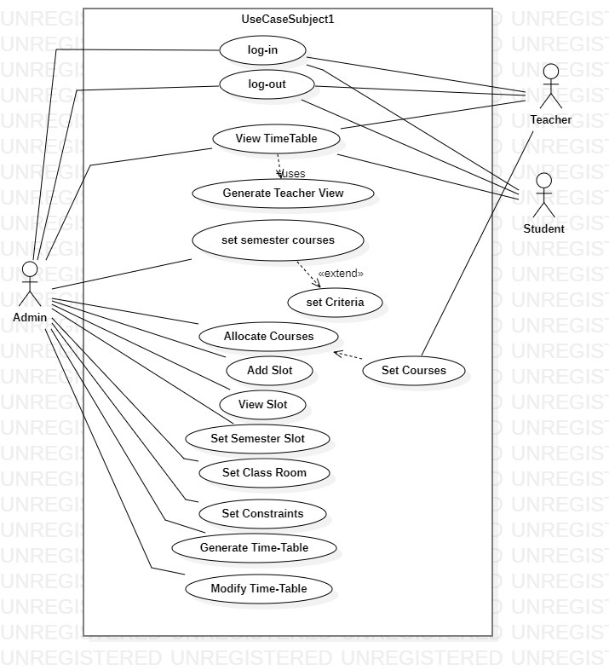

## 

## 2.2 Use Cases Distribution

|  |  |  |
| --- | --- | --- |
| S#. | Group Member | Assigned Use Cases |
| 1 | <BASIT IQBAL>  <FA21-BSE-050> | UC 1 : Login  UC 2 : Logout |
| 2 | <Fatima Aftab>  <FA21-BSE-088> | UC 3 : Generate timetable.  UC 4 : Modify Timetable |
| 3 | <Waleed Rashid>  <FA21-BSE-162> | UC 5 : Set slots.  UC 6 : Add slots.  UC 7 : View slots |
| 4 | <Ahmed Tariq>  <FA21-BSE-048> | UC 8 : Set semester’s courses.  UC 9 : Set Constrains.  UC 10 : Set criteria |
| 5 | <Eissa Masood>  <FA21-BSE-086> | UC 11 : Allocate courses.  UC 12 : select rooms.  UC 13 : select courses. |
| 6 | <Ebadat Nissa Khan>  <FA21-BSE-085> | UC 14 : View Timetable  UC 15 : View Teachers Timetable  UC 16 : View Timetable by Student |

## 2.3 Brief Level Use Cases

### Eissa Masood (FA21-BSE-086)

#### Use Case: Allocate Courses

The Timetable Management System for a university is a crucial tool for allocating courses to the timetable for each academic term. The primary actor in this use case is the System Admin, who logs into the system and selects the academic term for which courses need to be allocated. The system displays the available courses, and the admin selects the courses to be allocated. The system checks for scheduling conflicts and suggests alternative options if necessary. The admin reviews and approves the suggested options, and the system assigns the courses to the timetable. If modifications are needed, the admin can modify the allocated courses by selecting the desired scheduling options. The updated timetable is generated and displayed in the system, and the courses are now allocated for the selected academic term.

### Eissa Masood (FA21-BSE-086)

#### Use Case: Select Rooms

The "Select Rooms" use case in a Timetable Management System allows Admin to select Rooms to teach the allocated courses. Once the courses have been allocated to the timetable, Admin assigns the room from the available list, and can further manage the rooms by adding, editing, or deleting them. The system displays a list of available rooms for the selected time slots and the room becomes visible to the students and faculty in the timetable. This use case ensures that each room is assigned to available teachers.

### . Eissa Masood (FA21-BSE-086)

#### Use Case: Select Courses

The “Select Courses” use case in a Time Table Management System allows Teachers to choose the courses they want to teach during a semester. Once the Teachers logs in to the system, they can browse through the available courses, filter them by different criteria such as course code, After selecting the desired courses, the system will generate a tentative timetable, taking into account the availability of each course and avoiding any scheduling conflicts of Teachers. This use case is a critical part of the Time Table Management System as it enables Teachers to plan their schedules efficiently and effectively, ensuring that they can attend all the required courses without any conflicts.

### Ebadat Nissa Khan (FA21-BSE-085)

#### Use Case: View time table

The "View Timetable" use case is a fundamental feature of the Timetable Management System for University. This use case enables students and teachers to view their class schedules for the current week or multiple weeks in advance. The system displays the timetable information accurately and in a user-friendly format, including the course code, course name, class start and end time, and class location. The success of this use case guarantees that students and teachers can plan their schedules, accordingly, attend their classes on time, and avoid any scheduling conflicts. The View Timetable use case occurs multiple times per week for each student and teacher, and it is essential to the success of the Timetable Management System.

### Ebadat Nissa Khan (FA21-BSE-085)

#### Use Case: View time student table

The "View Timetable by Student" is a use case within the Timetable Management System for University, which allows students to access their class schedules. This use case is of high importance, as it ensures that students have a clear understanding of their class schedules and can attend their classes on time. The use case occurs at the user goal level, meaning it is a significant task that students need to accomplish to achieve their academic goals. The primary actor for this use case is the student, and the stakeholders are the faculty and university administration. The student must have an active account in the system and have already enrolled in the classes they wish to view on the timetable. The success of this use case guarantees that students can view their timetable with accurate information and plan their schedules accordingly. It occurs multiple times per week for each student and is critical to the success of the Time Table Management System.

### Ebadat Nissa Khan (FA21-BSE-085)

#### Use Case: View teacher time table

The "View Timetable by Teacher" is a use case within the Timetable Management System for University, which allows teachers to access their class schedules. This use case is of high importance, as it ensures that teachers have a clear understanding of their class schedules and can attend their classes on time. The use case occurs at the user goal level, meaning it is a significant task that teachers need to accomplish to achieve their academic goals. The primary actor for this use case is the teacher, and the stakeholders are the faculty and university administration. The teacher must have an active account in the system and have already been assigned to the classes they wish to view on the timetable. The success of this use case guarantees that teachers can view their timetable with accurate information and plan their schedules accordingly.

### Ahmed Tariq (FA21-BSE-048)

#### Use Case: Set semester courses.

### In a timetable management system, set semester courses are the courses that are offered during a specific semester or academic term. These courses can be categorized based on various factors such as course code, course name, level of difficulty, number of credits, and course prerequisites.

### Set semester courses are important for a timetable management system as they form the basis for creating the class schedule for that semester. The system needs to ensure that all courses offered in a particular semester are scheduled in such a way that there are no conflicts in the course schedules.

### To manage semester courses effectively, a timetable management system may use different techniques such as clustering courses based on similarity, grouping courses based on the availability of the required resources such as classrooms and lab equipment, and scheduling courses based on student demand and faculty availability.

### By effectively managing set semester courses in a timetable management system, administrators can ensure that students are able to complete the required courses within the specified time frame and are able to graduate on time. Moreover, a well-managed course schedule can reduce scheduling conflicts, maximize the use of resources, and improve the overall efficiency of the academic program.

### Ahmed Tariq (FA21-BSE-048)

#### Use Case: Set Criteria

In a timetable management system, set criteria are used to determine how the schedule is generated. These criteria can be defined based on various factors, such as student preferences, teacher workload, room availability, and overall program requirements.

Some common set criteria that might be used in a timetable management system include:

1. Student preferences: This criterion considers the preferences of individual students when scheduling their classes. For example, some students may prefer to have their classes scheduled in the morning, while others may prefer afternoon or evening classes.
2. Teacher workload: This criterion ensures that each teacher is assigned a workload that is appropriate for their level of experience and expertise. For example, new teachers may be assigned fewer classes than experienced teachers.
3. Room availability: This criterion ensures that each class is scheduled in an available classroom that is appropriate for the class size and equipment needs. For example, a class that requires a computer lab may be scheduled in a room with the necessary equipment.
4. Program requirements: This criterion ensures that the schedule meets the overall requirements of the academic program. For example, a program may require that certain classes be taken in a specific order, or that certain classes be completed before graduation.

By defining and applying set criteria in a timetable management system, administrators can generate schedules that are efficient, effective, and meet the needs of all stakeholders involved. Set criteria help to ensure that resources are utilized effectively, scheduling conflicts are minimized, and optimal learning outcomes are achieved for all students.

### Ahmed Tariq (FA21-BSE-048)

#### Use Case: Set Constrains

#### In a timetable management system, set constraints are used to ensure that the schedule meets certain conditions or requirements. These constraints can take various forms, including course availability, classroom availability, teacher availability, student availability, and room capacity.

#### Course availability constraints ensure that each course is scheduled during specific days and times. Classroom availability constraints ensure that each class is assigned to an available classroom. Teacher availability constraints ensure that each teacher is available to teach during the scheduled time slot. Student availability constraints ensure that each student can attend all their registered classes without conflicts. Room capacity constraints ensure that each class is assigned to a classroom with sufficient capacity.

#### By incorporating these and other set constraints, a timetable management system can generate a schedule that is efficient, effective, and meets the needs of all stakeholders involved, including students, teachers, and administrators. Set constraints help to prevent scheduling conflicts, ensure that resources are utilized effectively, and promote optimal learning outcomes for all students.

### Waleed Rashid (FA21-BSE-162)

#### Use Case: Manage slots.

|  |
| --- |

The academic administrator can add a new slot to the timetable by selecting a course or exam, assigning it to an available room, and choosing a suitable time slot. The academic administrator can modify an existing slot by changing the room or time slot, or by reassigning the course or exam to another faculty member. The system should automatically update the timetable and notify all stakeholders of the change. The academic administrator can view all available slots, including those already assigned and those that are still open. The system should provide filters and search options to help the administrator locate specific slots.

### Fatima Aftab (FA21-BSE-088)

#### Use Case: Generate Timetable

The "generate timetable" use case involves the generation of a schedule for a specific time based on predefined criteria such as course offerings, class size, available classrooms, slots, and teacher availability. The Admin selects the criteria and inputs the necessary data, such as course names, class sizes, slots, and teacher schedules, into the system. The system then uses an algorithm to generate a timetable that meets all the specified criteria, while also considering any constraints, such as avoiding scheduling conflicts or ensuring that certain courses are offered at specific times. Once the timetable has been generated, the Admin can review and modify it as necessary before finalizing it. The generated timetable can then be printed or exported for distribution to students, and teachers.

### Fatima Aftab (FA21-BSE-088)

#### Use Case: Modify Timetable

"Modify timetable" is a critical use case for a university timetable generation system. It involves making changes to the schedule to adapt to various circumstances, such as course offerings, student preferences, and resource utilization. This use case is important to avoid scheduling conflicts and ensure that students have access to the courses they need. By modifying the system, universities can create a schedule that meets the needs of students and faculty, maximizes the use of resources, and provides the best possible learning experience. Ultimately, a flexible and adaptable timetable generation system is crucial to the success of any academic institution.

### BASIT IQBAL (FA21-BSE-050)

#### Use Case: Login

The Login use case for the University Timetable Generation System allows users, including admins, teachers, and students, to efficiently log in to the system using their valid username and password. Upon navigating to the login page, the user enters their credentials, and the system verifies their identity. If the credentials are correct, the user gains access to the system, enabling them to perform actions within it. In case of any exceptions, such as incorrect login details, the system displays an error message and prompts the user to try again.

### BASIT IQBAL (FA21-BSE-050)

#### Use Case: Logout

The Log Out use case in the University Timetable Generation System allows the Admin, student, and teacher to log out of the system to ensure the privacy and security of their accounts. The user must be currently logged in to the system, and have access to the internet. The success guarantee of this use case is that the user is logged out of the system and redirected to the login screen. The main success scenario involves the user clicking on the "Log out" button or link in the user interface, the system logging the user out by invalidating their session token or cookie, and redirecting the user to the login screen. Exceptions include automatic log out due to session timeout, error during the log out process, and user already being logged out. The Timetable Management System should be user-friendly and regularly updated, and appropriate security measures should be in place to protect user data and prevent unauthorized access.

## 2.4 Fully Dressed Use Cases

### BASIT IQBAL (FA21-BSE-050)

| Use Case UC1: Login |
| --- |

|  |  |
| --- | --- |
| Use Case Section | Comments |
| Use Case Name | Login |
| Scope | University Timetable Generation System |
| Level | User Goal |
| Primary Actor. | Admin, student, teacher |
| Stakeholders and interest | * System Admin: Wants to efficiently login to the system to use the services being offered by the system. * Teachers: Wants to efficiently login to the system to use the services being offered by the system. * Students: Wants to efficiently login to the system to use the services being offered by the system. |
| Preconditions | The User must have a valid username and password (i.e Registration must have been completed). |
| Success Guarantee | The user is logged in to the system and can perform actions within it |
| Main Success Scenario | 1. The user navigates to the login page 2. The user enters their username and password 3. The system verifies the user's credentials. 4. If the credentials are correct, the system grants access to the system and the user can perform actions within it. |
| Exceptions | 1. If the user enters an incorrect username or password, the system displays an error message and prompts the user to try again. 2. If the user forgets their password, they can click on the "Forgot Password" link and follow the password recovery process. |
| Special Requirements | * The Timetable Management System should be user-friendly and easy to navigate. * The system should provide a clear overview of the available courses and their scheduling options. * The system should allow for easy modifications to the allocated courses. |
| Technology and data  variation list. | * The Timetable Management System can be accessed from a web browser or a dedicated application. * The system should be compatible with various operating systems and devices. * The list of available courses may vary depending on the academic term and the university's course offerings. |
| Frequency of occurrences | This use case occurs at the beginning when the user navigates to the website of the university timetable generation system or open the desktop application |
| Miscellaneous | * The Timetable Management System should be regularly updated and maintained to ensure optimal performance and usability. * The system should have appropriate security measures in place to protect user data and prevent unauthorized access. |

### BASIT IQBAL (FA21-BSE-050)

| Use Case UC2: Log out |
| --- |

|  |  |
| --- | --- |
| Use Case Section | Comments |
| Use Case Name | Log Out |
| Scope | University Timetable Generation System |
| Level | User Goal |
| Primary Actor. | Admin, student, teacher |
| Stakeholders and interest | * System Admin: Wants to logout off the system after using the services and wants privacy and security of the account. * Faculty Members: Wants to logout off the system after using the services and wants privacy and security of the account. * Students: Wants to logout off the system after using the services and wants privacy and security of the account. |
| Preconditions | * The user is currently logged in to the system. * The user has access to the internet. |
| Success Guarantee | * The user is logged out of the system. * The user is redirected to the login screen. |
| Main Success Scenario | * The user clicks on the "Log out" button or link in the user interface. * The system logs the user out by invalidating their session token or cookie. * The system redirects the user to the login screen. |
| Exceptions | 1. Automatic log out due to session timeout:   If the user's session has been inactive for a certain period of time, the system automatically logs the user out and invalidates their session token or cookie.  The system displays a message to the user indicating that they have been logged out due to inactivity and redirects them to the login screen.   1. Error during log out process:   If an error occurs during the log out process, such as the system being unable to invalidate the session token or cookie, the system displays an error message to the user and asks them to try again or contact support.   1. User is already logged out:   If the user has already been logged out, either by clicking the "Log out" button or automatically due to a session timeout, the system displays a message to the user indicating that they are already logged out and redirects them to the login screen. |
| Special Requirements | * The Timetable Management System should be user-friendly and easy to navigate. * The system should provide a clear overview of the available courses and their scheduling options. * The system should allow for easy modifications to the allocated courses. |
| Technology and data  variation list. | * The Timetable Management System can be accessed from a web browser or a dedicated application. * The system should be compatible with various operating systems and devices. * The list of available courses may vary depending on the academic term and the university's course offerings. |
| Frequency of occurrences | This use case occurs at the last when the user navigates to the website of the university timetable generation system or open the desktop application and has performed all the actions of his choice and wants to leave the system by clicking on logout. |
| Miscellaneous | * The Timetable Management System should be regularly updated and maintained to ensure optimal performance and usability. * The system should have appropriate security measures in place to protect user data and prevent unauthorized access. |

### 

### Waleed Rashid(FA21-BSE-162)

| Use Case UC1: Manage slots |
| --- |

|  |  |
| --- | --- |
| Use Case Name | Manage Slot in Timetable Management System for University |
| Scope | Timetable Management System for the university |
| Level | User Goal Level |
| Primary Actor | Academic Administrator |
| Stakeholders and Interests | **Faculty**: Interested in having their classes scheduled at appropriate times and rooms  **Students**: Interested in having their classes scheduled without any conflicts and preferences considered  **Room** Administrators: Interested in ensuring that rooms are utilized efficiently and not overbooked.  **University** Administration: Interested in efficient scheduling to maximize resource utilization and minimize conflicts |
| Precondition | The administrator is authenticated and authorized to access the Timetable Management System, and the timetable is set up with the available courses, faculty, rooms, and other resources |
| Success Guarantee | Successful scheduling of classes, labs, and exams without any conflicts or overbooking of resources |
| Main Success Scenarios | The administrator selects the course or exam for which the slot needs to be scheduled.  The system presents the available time slots for the selected course/exam and checks for any conflicts.  The administrator selects the appropriate time slot and assigns it to the course/exam.  The system updates the timetable and notifies the faculty and students of the new schedule. |
| Exceptions | If there are no available time slots, the system alerts the administrator and suggests alternative solutions.  If there is a conflict with a previously scheduled course or exam, the system alerts the administrator and suggests alternative time slots or adjustments to the existing schedule.  if there are not enough resources (such as rooms or faculty) to schedule a course or exam, the system alerts the administrator and suggests alternative solutions. |
| Special Requirements | The system should be able to handle multiple constraints such as avoiding time conflicts, ensuring the availability of required equipment, and accommodating student preferences as much as possible. |
| Technology and Data Variation List | The system should be able to integrate with the university's existing information systems and databases, including course catalogs, faculty information, and room availability data. |
| Frequency of Occurrences | Multiple times per academic term, typically during the course scheduling and exam scheduling periods. |
| Prototype | A prototype of the system should be developed and tested with input from faculty, students, and administrators to ensure it meets their needs and expectations. |
| Miscellaneous | This use case is critical for the efficient operation of the university and can have a significant impact on the academic success of faculty and students. Therefore, it should be designed and implemented with care and attention to detail. |
| Use Case Section | Time Table Management |
| Primary Actors | Academic Administrator |
| Secondary Actors | Faculty, Students, Room Administrators, University Administration |
| Preconditions | The administrator is authenticated and authorized to access the Time Table Management System, and the timetable is set up with the available courses, faculty, rooms, and other resources |
| Post conditions | The system updates the timetable and notifies the faculty and students of the new schedule. |
| Related Use Cases | Manage Course, Manage Exam, Manage Room, Manage Faculty |
| Special Requirements | The system should be able to handle multiple constraints such as avoiding time conflicts, ensuring the availability of required equipment, and accommodating student preferences as much as possible. |

### Eissa Masood (FA21-BSE-086)

| Use Case UC1: Allocate Course |
| --- |

|  |  |
| --- | --- |
| Use Case Section | Comments |
| Use Case Name | Allocate Courses |
| Scope | This use case describes the process of allocating courses to the timetable for a new academic term in the Timetable Management System. |
| level | User Goal |
| Primary Actor. | Admin |
| Stakeholders and interest | * System Admin: Wants to efficiently allocate courses to the timetable for each academic term. * Faculty Members: Want to ensure that their courses are allocated to the timetable at a convenient time and day. * Students: Want a well-structured and organized timetable that minimizes scheduling conflicts and allows for an optimal learning experience. |
| Preconditions | The Timetable Management System is operational.  The Admin has the necessary login credentials to access the system.  The list of available courses for the academic term is available in the system. |
| Success Guarantee | The courses are allocated to the timetable , and the updated timetable is generated and displayed in the system |
| Main Success Scenario | 1. The admin logs into the Timetable Management System. 2. The system displays the list of available courses for the selected term. 3. The admin selects the courses that need to be allocated to the timetable. 4. The admin approves the suggested scheduling options. 5. The system assigns the courses to the timetable. 6. The system generates and displays the updated timetable. |
| Exceptions | 1. If the Timetable Management System is not operational, the use case cannot proceed. 2. If the admin does not have the necessary login credentials, they cannot access the system. |
| Special Requirements | * The Timetable Management System should be user-friendly and easy to navigate. * The system should provide a clear overview of the available courses and their scheduling options. * The system should allow for easy modifications to the allocated courses. |
| Technology and data  variation list. | * The Timetable Management System can be accessed from a web browser or a dedicated application. * The system should be compatible with various operating systems and devices. * The list of available courses may vary depending on the academic term and the university's course offerings. |
| Frequency of occurrences | This use case occurs at the beginning of each academic term, typically once a year. |
| Miscellaneous | * The Timetable Management System should be regularly updated and maintained to ensure optimal performance and usability. * The system should have appropriate security measures in place to protect user data and prevent unauthorized access. |

### Eissa Masood (FA21-BSE-086)

| Use Case UC1: Select Courses |
| --- |

|  |  |
| --- | --- |
| Use Case Section | Comments |
| Use Case Name | Select Courses |
| Scope | This use case describes the process of allowing Teachers to Select a Course during a semester in the Timetable Management System. |
| level | User Goal |
| Primary Actor. | Teacher |
| Stakeholders and interest | * Teachers: Interested in selecting the courses they want to take and planning their schedules accordingly. * Admin: Interested in managing the course offerings, scheduling, and allocating resources efficiently. * Students: Interested in knowing the number of class fellows enrolled in their courses. |
| Preconditions | * The Teacher is registered with the University. * The Teachers has logged in to the Time Table Management System. * The course offerings for the current semester are available in the system. |
| Success Guarantee | * The Teachers successfully selects the courses they want to teach. * The system generates a tentative timetable that avoids any scheduling conflicts. |
| Main Success Scenario | 1. The Teacher logs in to the Time Table Management System. 2. The system displays the available courses for the current semester. 3. The Teacher filters the courses based on criteria such as course code. 4. The Teacher selects the desired courses. 5. The system generates a tentative timetable that avoids any scheduling conflicts. 6. The Teacher reviews and confirms their selection. |
| Exceptions | 1. The Teacher selects courses that have scheduling conflicts. 2. The system fails to generate a tentative timetable due to resource constraints. |
| Special Requirements | * The system should provide a clear overview of the available courses and their scheduling options. |
| Technology and data  Variation list. | * The Time Table Management System should be accessible via a web-based interface. * The system should store course data, student data, and scheduling data in a relational database. |
| Frequency of occurrences | This use case occurs at the beginning of each semester when teacher plan their schedules. |
| Miscellaneous | * The system should allow teacher to view their course schedules and receive notifications regarding any changes or updates. |

### Eissa Masood (FA21-BSE-086)

| Use Case UC1: Select Rooms |
| --- |

|  |  |
| --- | --- |
| Use Case Section | Comments |
| Use Case Name | Select Rooms |
| Scope | This use case describes the process of selecting and assigning a room to an allocated course in the Timetable Management System. |
| level | User Goal |
| Primary Actor. | Admin` |
| Stakeholders and interest | * Admin: Wants to efficiently assign available rooms to the allocated courses. * Teachers: wants to view available rooms that are available for their respective courses. * Students: want to know the location and availability of rooms for their classes. |
| Preconditions | * The Teachers and Students must have access to the Time Table Management System. * The courses must be scheduled and the rooms must be available in the system.   . |
| Success Guarantee | The selected rooms are assigned to the allocated course, and the updated timetable is generated and displayed in the system. |
| Main Success Scenario | 1. The Admin logs into the Timetable Management System. 2. The system displays a list of rooms for the selected time slot. 3. The Admin selects the desired rooms from the list. 4. The system checks for any scheduling conflicts with the teacher's existing assignments. 5. The system generates and displays the updated timetable. |
| Exceptions | 1. If the Timetable Management System is not operational, the use case cannot proceed. 2. If the Admin does not have the necessary login credentials they will need to contact IT Support Center of the University. 3. If the courses have not been allocated to the timetable, a room cannot be selected by the Admin. |
| Special Requirements | * The Timetable Management System should display the current availability of rooms in real-time. |
| Technology and data  Variation list. | * The Time Table Management System should be able to integrate with other systems to display real-time room availability. |
| Frequency of occurrences | This use case occurs whenever a new academic  term starts. |
| Miscellaneous | * The Timetable Management System should be regularly updated and maintained to ensure optimal performance and usability. * The system should be able to handle multiple teacher assignments for different rooms and time slots. * The room selection process should be straightforward and easy to use. |

**EBADAT NISA KHAN**

**VIEW TIMETABLE**

|  |  |
| --- | --- |
| Use Case Section | Comments |
| Use Case Name | View Timetable |
| Scope | Scheduling of classes or instructors |
| Main Success Scenario | Tthe system displays the student's course schedule in a user-friendly format, showing the course name, course code, instructor, time, and location of each class. |
| Preconditions | The student must be logged in to their account on the online student portal. |
| Primary Actors | Students,Teachers |
| Level | Higher level to meet requirement. |
| Stakeholders | Faculty,University administrators,IT staff |
| Success Guarantee | Thee system should be able to retrieve and display the course schedule data from the university's database accurately, showing the course name, teacher, time, and room. |
| Exceptions | Course schedule changes: If there are changes to the course schedule after the student has viewed it, the system may not reflect the updated information until the data is refreshed,Conflicting schedule,Login error. |
| Special Requirements | Security,Compatibility,Scalabilty,Performance |
| Technology and data variation list | Client-side technologies such as HTML, CSS, JavaScript for building the user interface of the online student portal.  List include as Course schedule data for different academic terms or semesters,courses,instructors,rooms. |
| Frequency of occurences | If there are changes to the course schedule, students may need to view their timetable more frequently to ensure they are up-to-date with any changes. |
| Miscellaneous | Regular updates,user testing,performance and efficiency. |
| Prototyping | Identify user requirement,Understand requirement,code or implement,test,development or maintainance. |

View Timetable by Teacher

EBADAT NISA KHAN

|  |  |
| --- | --- |
| Use Case Section | Comments |
| Use Case Name | View Timetable by Teacher |
| Scope | TimeTable Management System . |
| Main Success Scenario | 1. The teacher logs into the TimeTable Management System. 2. The system presents the teacher with their dashboard. 3. The teacher selects the "View Timetable" option. 4. The system displays the timetable of classes the teacher is assigned to teach, including the time, date, and location of each class. |
| Preconditions | 1The teacher must be registered and authenticated in the Timetable Management System.  2.The timetable must be created and available in the system |
| Primary Actors | Teacher. |
| Level | User Goal |
| Stakeholders | Teacher, Students, University Administration |
| Success Guarantee | The teacher can view their timetable accurately and without any errors. |
| Exceptions | 1. The teacher is not registered in the system: The system displays an error message. 2. The teacher is not assigned to any classes: The system displays a message informing the teacher that they have no classes assigned to them. 3. The timetable has not been created or is unavailable: The system displays an error message. 4. The teacher encounters technical issues: The system provides support to help resolve the issue. |
| Special Requirements | * The system should be accessible via a web browser or mobile app. * The timetable should be updated in real-time to reflect any changes made. |
| Technology and data variation list | * The system should be compatible with popular web browsers such as Chrome, Firefox, and Safari. * The system should be able to display the timetable on different devices with varying screen sizes and resolutions. * The system should be able to handle a large number of users accessing the timetable at the same time. |
| Frequency of occurences | The teacher will view their timetable multiple times per week, or whenever they need to know their schedule. |
| Miscellaneous | * The system should provide a way for the teacher to report any errors or conflicts they encounter in their timetable. * The system should ensure that the teacher's personal information is kept confidential and secure. |
| Prototyping | Requirement gathering,testing,implementing,delivery. |

View Timetable by STUDENT

EBADAT NISA KHAN FA21-BSE-085)

|  |  |
| --- | --- |
| Use Case Section | Comments |
| Use Case Name | View Timetable by Student |
| Scope | Timetable Management System . |
| Main Success Scenario | **The student selects the "View Timetable" option and also the system displays the student's timetable for the current week with accurate information.** |
| Preconditions | The student must have already enrolled in the classes they wish to view on the timetable. |
| Primary Actors | Student |
| Level | User Goal |
| Stakeholders | Teacher, Students, University Administration |
| Success Guarantee | The student can view their timetable with accurate information. |
| Exceptions | 1. If the student enters invalid login credentials, the system prompts the student to enter valid credentials and returns to step 1. 2. If the student has not enrolled in any classes, the system displays an error message informing the student that they have no classes and returns to step 2. |
| Special Requirements | The system must display the timetable information accurately and in a user-friendly format. |
| Technology and data variation list | * The Timetable Management System should be compatible with web browsers, desktop computers, and mobile devices. * The system should display the timetable information in a clear and easy-to-read format. |
| Frequency of occurences | The View Timetable use case will occur multiple times per week for each student. |
| Miscellaneous | The View Timetable use case is a critical feature of the TimeTable Management System, as it provides essential information to students about their class schedules. |
| Prototyping | Identify user requirement,Understand requirement,code or implement,test,development or maintainance. |

### Ahmed Tariq (FA21-BSE-048)

| Use Case UC1: Manage slots |
| --- |

|  |  |
| --- | --- |
| Use Case Section | Comments |
| Use Case Name | Manage Courses |
| Scope | This use case involves managing courses offered by the University within the Timetable Management System. |
| Main Success Scenarios | 1. The University Administrator creates a new course, specifying the course name, course code, prerequisites, credit hours, and the professor who will teach the course.  2. The University Administrator updates an existing course, changing information such as course name, prerequisites, or professor.  3. The University Administrator deletes a course from the system.  4. The University Administrator assigns a course to a classroom, specifying the time and day(s) of the week the course will be offered. |
| Level | User goal |
| Primary Actor | University Administrator |
| Stakeholders | Professors, Students, University Administration, |
| Preconditions | - The University Administrator is logged in to the Timetable Management System.  - The relevant course information (e.g., course name, course code, prerequisites, credit hours) is available. |
| Success Guarantee | The Timetable Management System accurately reflects the course offerings for the University. |
| Exceptions | 1. The course code already exists in the system, and the University Administrator must choose a different code. 2. The professor assigned to the course is not available during the specified time and day(s) of the week, and the Administrator must choose a different professor. 3. The classroom assigned to the course is not available during the specified time and day(s) of the week, and the Administrator must choose a different classroom. |
| Special Requirements | - The TimeTable Management System must be able to generate accurate course schedules based on the courses assigned to each classroom. |
|  |  |
| Technology and Data Variations List | - The TimeTable Management System should be accessible through a web interface.  - The course information must be stored in a database. |
| Frequency of Occurrences | This use case will be performed frequently, as courses are added, updated, and deleted each semester. |
|  |  |
| Miscellaneous | The University Administrator may also need to assign multiple professors to a course if it is a team-taught course. |

### Ahmed Tariq (FA21-BSE-162)

| Use Case UC1: Add courses |
| --- |

|  |  |
| --- | --- |
| Use Case Section | Comments |
| Use Case Name | Add Courses |
| Scope | This use case involves adding new courses to the TimeTable Management System for the University. It includes specifying course details such as course name, course code, prerequisites, credit hours, and assigning the course to a professor and classroom. |
| Main Success Scenarios | The University Administrator enters the course name, course code, prerequisites, credit hours, and other details into the TimeTable Management System.  The Administrator assigns the course to a professor who is qualified to teach the course.  The Administrator assigns the course to a classroom, specifying the time and day(s) of the week the course will be offered. |
| Level | User goal |
| Primary Actor | University Administrator |
| Stakeholders | Professors, Students, University Administration, |
| Preconditions | The University Administrator is logged in to the TimeTable Management System.  The relevant course information (e.g., course name, course code, prerequisites, credit hours) is available. |
| Success Guarantee | The new course is accurately reflected in the TimeTable Management System and can be assigned to a professor and classroom. |
| Exceptions | The course code already exists in the system, and the University Administrator must choose a different code.  The professor assigned to the course is not available during the specified time and day(s) of the week, and the Administrator must choose a different professor.  The classroom assigned to the course is not available during the specified time and day(s) of the week, and the Administrator must choose a different classroom. |
| Special Requirements | The TimeTable Management System must be able to generate accurate course schedules based on the courses assigned to each classroom. |
|  |  |
| Technology and Data Variations List | The TimeTable Management System should be accessible through a web interface.  The course information must be stored in a database. |
| Frequency of Occurrences | This use case will be performed frequently as new courses are added each semester. |
|  |  |
| Miscellaneous | The University Administrator may also need to assign multiple professors to a course if it is a team-taught course.  The course may have multiple sections that need to be assigned to different professors and classrooms. |
|  |  |
|  |  |
|  |  |
|  |  |
|  |  |

### Ahmed Tariq (FA21-BSE-162)

| Use Case UC1: Manage rooms |
| --- |

|  |  |
| --- | --- |
| Use Case Section | Comments |
| Use Case Name | Manage Rooms |
| Scope | This use case involves managing classrooms in the Timetable Management System for the University. It includes adding new classrooms, modifying existing ones, and removing classrooms. |
| Main Success Scenarios | The University Administrator adds a new classroom to the Timetable Management System, specifying the room number, capacity, and any special equipment available in the classroom.  The Administrator modifies an existing classroom by updating its information (e.g., capacity, equipment).  The Administrator removes a classroom that is no longer available for use. |
| Level | User goal |
| Primary Actor | University Administrator |
| Stakeholders | Professors, Students, University Administration, |
| Preconditions | - The University Administrator is logged in to the Timetable Management System.  The relevant classroom information (e.g., room number, capacity, equipment) is available.  Success Guarantee: The classroom information is accurately reflected in the Timetable Management System, and the classroom can be assigned to courses as needed. |
| Success Guarantee | classroom information is accurately reflected in the Timetable Management System, and the classroom can be assigned to courses as needed. |
| Exceptions | The room number already exists in the system, and the University Administrator must choose a different room number.  The Administrator attempts to remove a classroom that is currently assigned to a course, and the system prompts them to reassign the course to a different classroom before removing the original classroom. |
| Special Requirements | The Timetable Management System must be able to generate accurate course schedules based on the classrooms available. |
|  |  |
| Technology and Data Variations List | The Timetable Management System should be accessible through a web interface.  The classroom information must be stored in a database. |
| Frequency of Occurrences | This use case will be performed frequently as new classrooms are added or modified, and old classrooms are removed or replaced. |
|  |  |
| Miscellaneous | The University Administrator may also need to assign multiple classrooms to a course if it has multiple sections or requires specialized equipment.  Prototype: A prototype of the system can be created to test the usability of the interface and the accuracy of the classroom scheduling algorithm. |
|  |  |
|  |  |
|  |  |
|  |  |
|  |  |

### FATIMA AFTAB (FA21-BSE-088)

| Use Case UC4: Generate Timetable |
| --- |

|  |  |
| --- | --- |
| Use Case Section | Comments |
| Use Case Name | Generate Timetable |
| Scope | University timetable |
| Main Success Scenarios | 1. The administrator selects the "Generate Timetable" option from the main menu. 2. The system displays a form where the administrator can enter the details of the timetable, such as the start and end date, the number of courses, the number of classrooms, and the number of students. 3. The administrator fills out the form and submits it to the system. 4. The system checks the validity of the input and generates a list of available time slots based on the input parameters. 5. The system uses an algorithm to generate a conflict-free timetable that allocates the available time slots to the courses and classrooms. 6. The system displays the generated timetable to the administrator. 7. The administrator reviews the timetable and verifies that it meets the requirements of the faculty and students. 8. If the timetable is satisfactory, the administrator approves it and saves it in the system. 9. If the timetable is not satisfactory, the administrator can modify and re-generate the timetable. |
| Level | User goal |
| Primary Actor | University Administrator |
| Stakeholders | * University administrator: Wants to generate an accurate and efficient timetable for the university to ensure that students and faculty can attend classes without conflicts. * Faculty: Need to know when and where their classes are scheduled. * Students: Need to know when and where their classes are scheduled. |
| Preconditions | * University administrator should login to the system. * The system has been set up with the necessary data, including course schedules, faculty availability, room availability, and other constraints. * The system has assigned courses to faculty members and recorded their preferences. |
| Success Guarantee | The system generates a timetable that meets the expectations and requirements of all stakeholders. |
| Exceptions | * If the system is unable to generate a conflict-free timetable, it should display an error message and prompt the Admin to modify the scheduling algorithm or parameters. * If there is a system error while generating the timetable, the system should display an error message and prompt the admin to try again later. * If there is a major change in faculty availability or course enrollment after the timetable has been generated, the admin may need to modify the schedule manually. |
| Special Requirements | The Timetable System must be able to generate accurate course schedules based on the classrooms available. |
|  |  |
| Technology and Data Variations List | * Object-Oriented Programming * Database Management Systems * Object Oriented Software Engineering * Web languages (html, CSS, react) * Course information may be updated between the time the timetable is generated and the start of the semester. * Faculty availability may change due to illness, scheduling conflicts, or other unforeseen circumstances. * Classroom availability may change due to maintenance or other scheduling conflicts |
| Frequency of Occurrences | * Once per semester for each university department. * If timetable is not accurate university administrator can also modify it. |
|  |  |
| Miscellaneous | * The system should be able to handle large amounts of data efficiently. * The system should be user-friendly and easy to navigate. * The system should be able to generate a timetable within a reasonable amount of time. |
|  |  |
|  |  |
|  |  |
|  |  |
|  |  |

### FATIMA AFTAB (FA21-BSE-088)

| Use Case UC5: Modify timetable |
| --- |

|  |  |
| --- | --- |
| Use Case Section | Comments |
| Use Case Name | Modify timetable |
| Scope | University Timetable |
| Level | User Goal |
| Primary Actor. | University Administrator |
| Stakeholders and interest | * University Administrator : A person who is responsible for managing and wants to make changes to the timetable in a quick and efficient manner. |
| Preconditions | * User authentication : The user must be authenticated and authorized as an administrator with the necessary permissions to make changes to the timetable. * Timetable existence : The timetable must already exist in the system for the administrator to modify it. |
| Success Guarantee | * The changes made by the administrator are accurately reflected in the timetable. * The timetable for teachers, and students are updated to reflect the changes made in it. |
| Main Success Scenario | * The administrator selects the "Modify Timetable" option from the system menu. * The administrator selects the course, teacher, or classroom they wish to modify from the available options. * The administrator modifies the schedule information for the selected course, teacher, or classroom as necessary. * The system updates the timetable to reflect the changes made by the administrator. * Faculty and students can access the updated schedules and any changes made to the timetable. |
| Exceptions | * The timetable the administrator is attempting to modify does not exist in the system. * The course, faculty, or classroom the administrator is attempting to modify does not exist in the system. * The changes made by the administrator result in a conflict with an existing schedule for a course, instructor, or classroom. * The administrator inputs invalid or incomplete schedule information, such as an incorrect time or room number. * A system error occurs during the modification process and prevents the changes from being correctly updated in the system. |
| Special Requirements | * Usability: The system should have a user-friendly interface that is easy for administrators to navigate and use to modify the timetable. * Security: The system should ensure that only authorized administrators with the appropriate permissions can modify the timetable, and that user data is securely stored and protected from unauthorized access or tampering. * Reliability: The system should be reliable and available for administrators to always use, with minimal downtime for maintenance or updates. |
| Technology and data  variation list. | * Object-Oriented Programming * Database Management Systems * Object Oriented Software Engineering * Web technologies (html,css,react) * Java for GUI |
| Frequency of occurrences | It depends upon the administrator that how many times he/she wants to modify timetable after the timetable has been generated. |
| Miscellaneous | * The system should be able to handle large amounts of data efficiently. * The system should be user-friendly and easy to navigate. * The system should be able to modify timetable correctly and update timetable for teachers, and students. |

### WALEED RASHID (FA21-BSE-162)

| Use Case UC5: Manage Slots |
| --- |

|  |  |
| --- | --- |
| Use Case Section | Comments |
| Use Case Name | Manage Slots |
| Scope | University Timetable Generation System |
| Level | User Goal |
| Primary Actor. | Admin, student, teacher |
| Stakeholders and interest | * System Admin: Interested in managing the course slots efficiently and ensuring the best use of resources.. * Teachers: Interested in having clear slots for their courses and avoiding scheduling conflicts. * Students: Interested in having a clear and organized timetable for their courses. |
| Preconditions | * The Admin must be logged into the TimeTable Management System. * The system must have access to the course details, instructor information, and available resources such as classrooms and equipment. |
| Success Guarantee | The system will successfully update the timetable with the new slot information and notify the relevant stakeholders. |
| Main Success Scenario | 1. The Admin selects the option to manage slots. 2. The system displays the list of courses with their existing slots. 3. The Course Coordinator selects a course to modify. 4. The system displays the details of the selected course, including the existing slots and their corresponding instructors and resources. 5. The Course Coordinator modifies the slots by adding, deleting or changing the time, location or instructor. 6. The system validates the modifications and checks for any conflicts with existing slots or resources. 7. If no conflicts are found, the system updates the timetable with the new slot information and notifies the relevant stakeholders. |
| Exceptions | 1. I f there are conflicts with existing slots or resources, the system alerts the Course Coordinator and provides possible solutions. 2. If there are technical issues or errors, the system displays an error message and prompts the Course Coordinator to try again later or contact technical support. |
| Special Requirements | * The system should allow the Course Coordinator to view the entire timetable or filter by course, instructor, time, or location. * The system should have a user-friendly interface with clear instructions and feedback messages. * Technology and Data Variations List * The system should be accessible from any device with a web browser and internet connection. * The system should be able to handle different types of course data, instructor data, and resource data formats. |
| Technology and data  variation list. | * The Timetable Management System can be accessed from a web browser or a dedicated application. * The system should be compatible with various operating systems and devices. * The list of available courses may vary depending on the academic term and the university's course offerings. |
| Frequency of occurrences | The Manage Slots use case can be performed multiple times per semester, as needed. |
| Miscellaneous | The Manage Slots use case is a critical function of the TimeTable Management System for University, as it enables efficient scheduling of courses, instructors, and resources. |

## Prototypes

### BASIT IQBAL

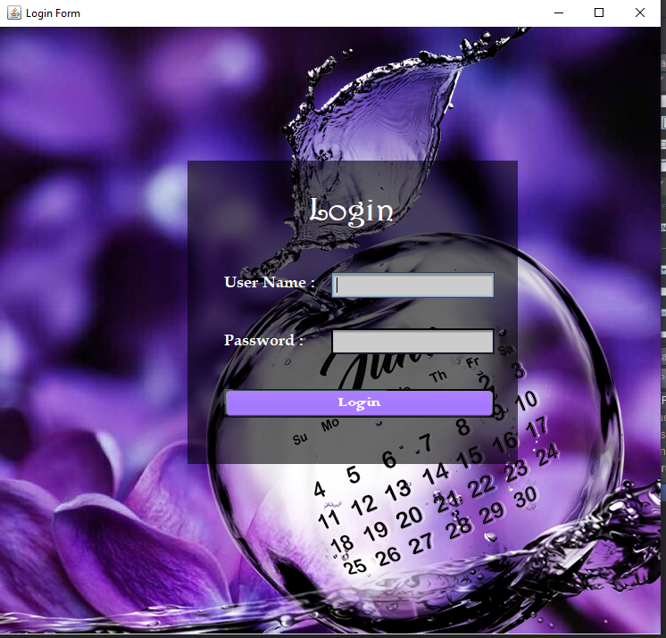

### Fatima Aftab

### Ebadat Nisa Khan- View timetable by student,View timetable by teacher.

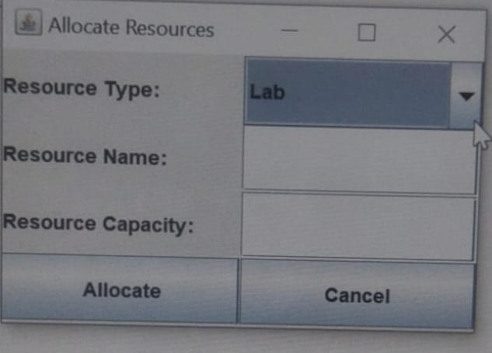

Eissa Masood (FA21-BSE-085)

# CHAPTER 3 DOMAIN MODEL 3.1 Individual Partial Domain Model

### UC 1,2 : Login & Logout (BASIT IQBAL ,FA21-BSE-050)

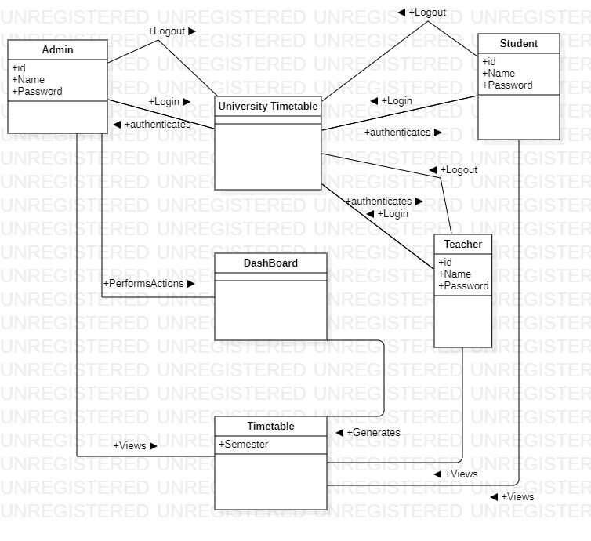

### UC 3,4 : Generate Timetable and Modify timetable (Fatima Aftab,Fa21-bse-088)

**View Timetable(Ebadat Nisa Khan, FA21-BSE-085)**

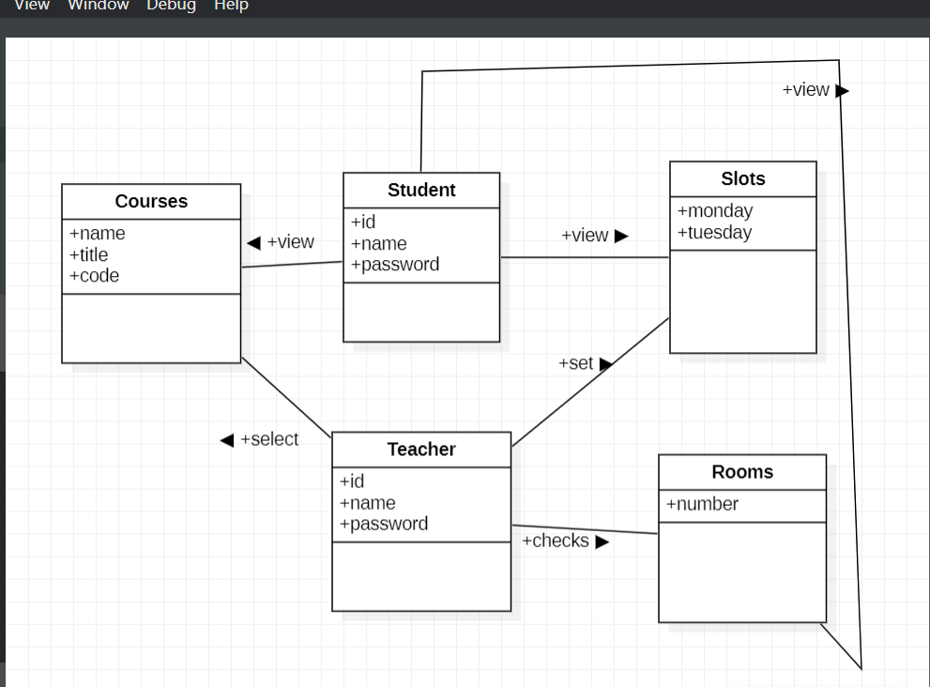

**Allocate Courses (Eissa Masood, FA21-BSE-086)**

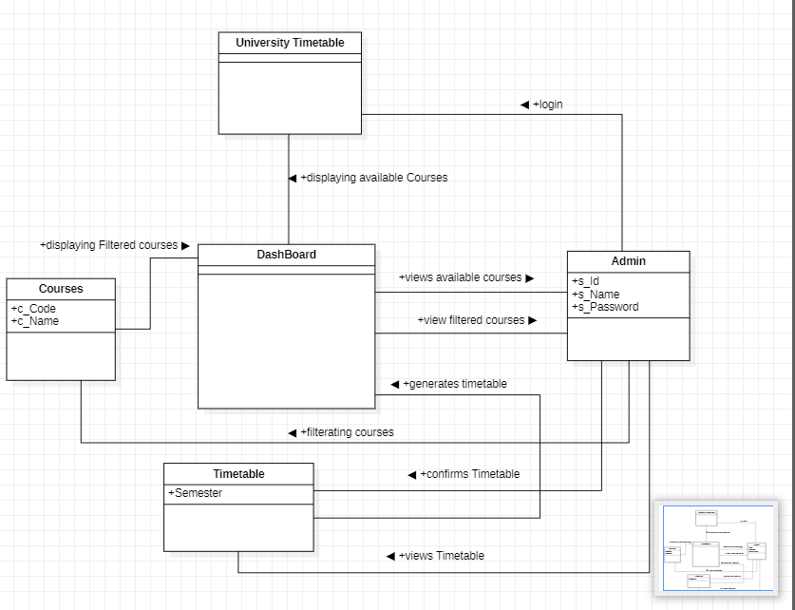

**Select Rooms (Eissa Masood, FA21-BSE-086)**

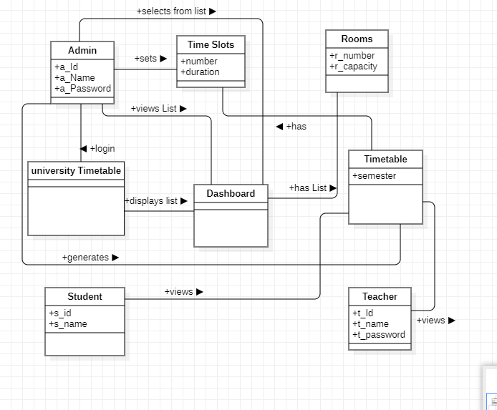

**Select Courses (Eissa Masood, FA21-BSE-086)**

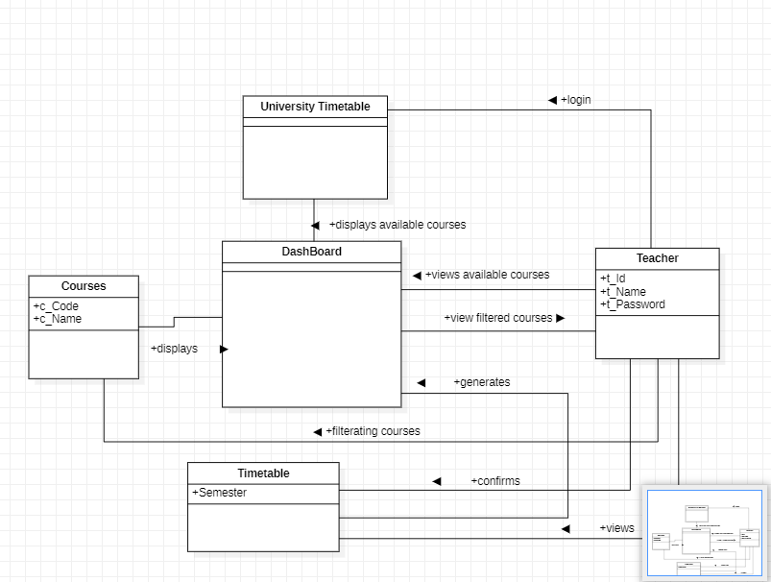

Integrated Domain Model

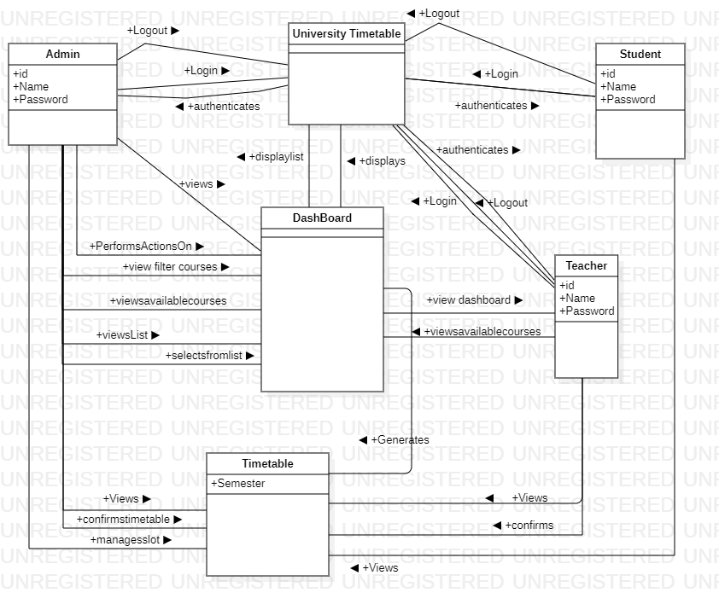

# CHAPTER 4 System Sequence Diagram (SSD)

### 4.1. LOGIN (BASIT IQBAL : FA21-BSE-050)

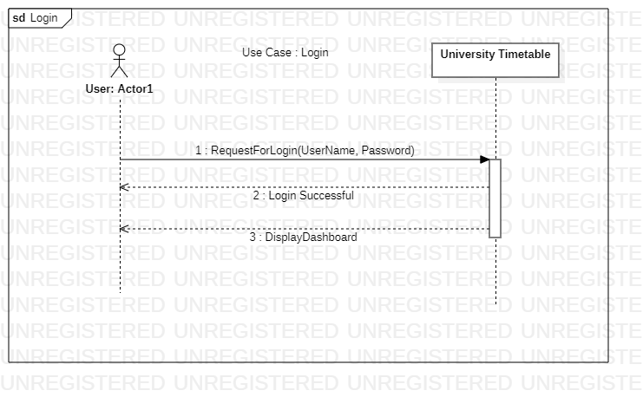

### Logout (BASIT IQBAL : FA21-BSE-050)

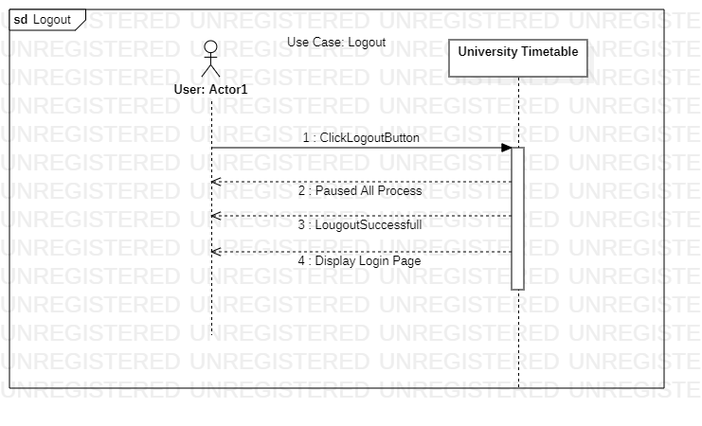

### Text Description automatically generatedGenerate Timetable Scenario (Fatima Aftab)

### Modify Timetable Scenario (Fatima Aftab)

### Manage Slots (Waleed Rashid)

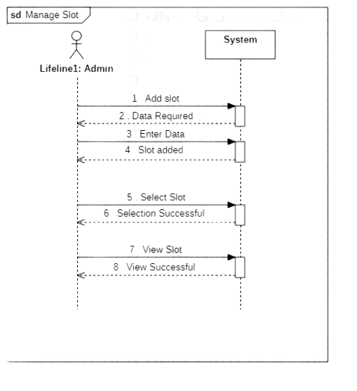

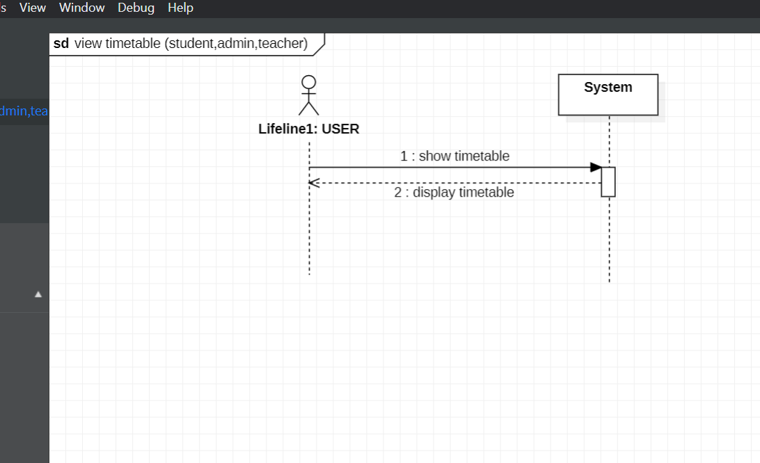

**SSD(VIEW TIMETABLE)ebadat nisa khan FA21-BSE-085**

**Allocate Courses (Eissa Masood, FA21-BSE-086)**

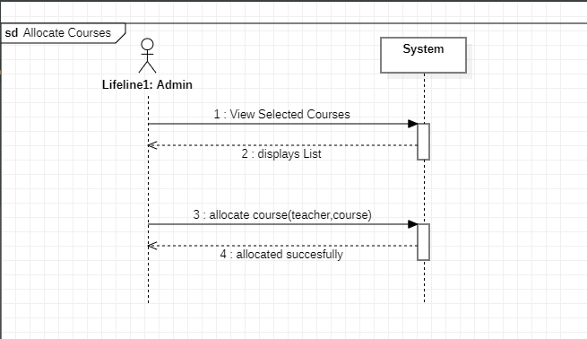

**Select Rooms (Eissa Masood, FA21-BSE-086)**

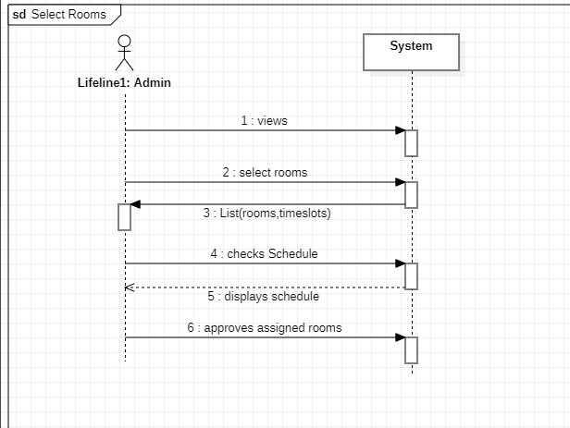

**Select Courses (Eissa Masood, FA21-BSE-086)**

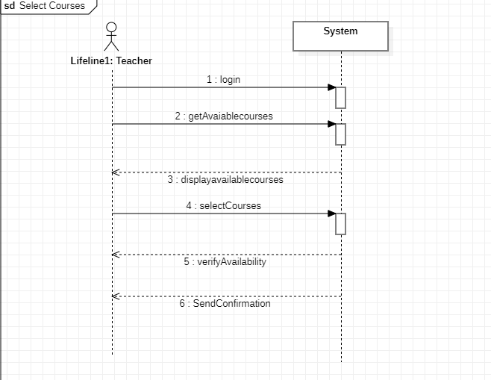

**Add Slot UI(Waleed rashid)**

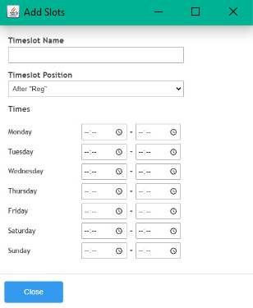

**Set Semester Course:**

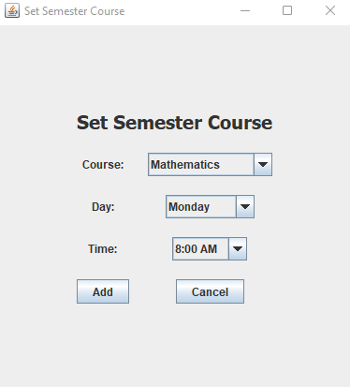

**Set Criteria:**

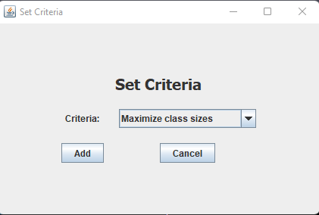

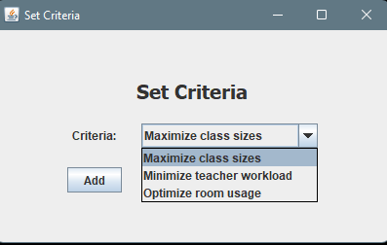

# CHAPTER 5 Operation Contracts (OC’s)

# 5.1. Login (BASIT IQBAL : FA21-BSE-050)

|  |  |
| --- | --- |
| Id | 01 |
| Operation | displayDashboard( ) |
| Cross Reference | Login |
| Pre Conditions | The user must have log in to the system by entering valid user name and password. |
| Post Conditions | The dashboard was displayed to the user when he entered correct user name and password.  If the user name of password was incorrect then the error message was displayed and the user was asked to reenter the user name and password. |

# Logout (BASIT IQBAL: FA21-BSE-050)

|  |  |
| --- | --- |
| Id | 02 |
| Operation | displayLoginPage( ) |
| Cross Reference | Logout |
| Pre Conditions | The user must have paused or canceled all the running processes and must have clicked on logout button. |
| Post Conditions | If all the process have been paused then the user was redirected to login page.  If the process have not been paused then the user was asked to close or pause the process. |

# Add slots (waleed rashid : FA21-BSE-162)

|  |  |
| --- | --- |
| Id | 01 |
| Operation | displaySlotspage( ) |
| Cross Reference | Add Slots |
| Pre Conditions | The user must have the necessary permissions or privileges to modify the time table.  The time table structure or database must already exist.  The necessary resources, such as memory or storage space, must be available.  Any required input data, such as the slot details (start time, end time, location, etc.), must be provided. |
| Post Conditions | The new slots are successfully added to the time table.  The time table reflects the updated schedule with the new slots.  Any relevant notifications or alerts are triggered or updated based on the changes.  The system may perform additional actions or calculations based on the updated time table, such as generating reports or adjusting other related schedules. |

# View slots (waleed rashid : FA21-BSE-162)

|  |  |
| --- | --- |
| Id | 01 |
| Operation | displaySlotspage ( ) |
| Cross Reference | View slots |
| Pre Conditions | The user must have the necessary permissions or privileges to access the time table.  The time table structure or database must already exist.  The time table must have slots defined or populated with relevant data.  Any required input data, such as the time range or filters for viewing specific slots, may need to be provided. |
| Post Conditions | The system displays the requested slots of the time table based on the provided criteria.  The user can see the details of each slot, such as the start time, end time, location, etc.  The time table remains unchanged after the view operation.  The user may have the option to perform additional actions on the viewed slots, such as editing, deleting, or exporting the information. |

# Select slots (waleed rashid : FA21-BSE-162)

|  |  |
| --- | --- |
| Id | 01 |
| Operation | displaySlots ( ) |
| Cross Reference | Select slots |
| Pre Conditions | The user must have the necessary permissions or privileges to access and select slots from the time table.  The time table structure or database must already exist.  The time table must have slots defined or populated with relevant data.  Any required input data, such as the criteria or filters for selecting specific slots, must be provided. |
| Post Conditions | The system retrieves and presents the selected slots from the time table based on the provided criteria.  The user can view the details of the selected slots, such as the start time, end time, location, etc.  The time table remains unchanged after the selection operation.  The user may have the option to perform additional actions on the selected slots, such as editing, deleting, or exporting the information. |

**Ocs EBADAT NISA KHAN (VIEW TIMETABLE)**

|  |  |
| --- | --- |
| Id | 01 |
| Operation | showTimetableByUser(userId: string) |
| Cross Reference | Login,View Timetable.Modify timetable,Mnage courses. |
| Pre Conditions | * The userId parameter is not null and represents a valid user ID. * The user with the specified userId exists in the system. * The user has at least one event in their timetable. |
| Post Conditions | * The timetable for the user with the specified userId is shown on the screen. * The events in the timetable are shown in chronological order. * The user can scroll through the timetable if there are more events than can be displayed at once. |

### Eissa Masood (FA21-BSE-086)

| Use Case UC1: Allocate Course |
| --- |

|  |  |
| --- | --- |
| Id | 01 |
| Operation | **viewSelectedCourseByAdmin (courseId: string)** |
| Cross Reference | Generate Timetable |
| Pre Conditions | * The courseId parameter is not null and represents a valid course ID. * The course with the specified courseId exists in the system. * The user performing the operation has administrative privileges. |
| Post Conditions | * The details of the selected course, including its schedule and enrolled students, are displayed on the view. * The course details are up-to-date and reflect any changes made to the course in the system. |

|  |  |
| --- | --- |
| Id | 02 |
| Operation | **viewAllocateCourseByAdmin(courseId: string)** |
| Cross Reference | View timetable |
| Pre Conditions | * The courseId parameter is not null and represents a valid course ID. * The course with the specified courseId exists in the system. * The user performing the operation has administrative privileges. |
| Post Conditions | * The allocation of the selected course, including its assigned instructors and classrooms, are displayed on the view. * The allocation details are up-to-date and reflect any changes made to the allocation in the system. |

### Eissa Masood (FA21-BSE-086)

Use Case UC2: select Rooms

|  |  |
| --- | --- |
| Id | 01 |
| Operation | **selectRoomsByAdmin(roomIds: List<string>, courseId: string)** |
| Cross Reference | Modify timetable |
| Pre Conditions | * The roomId parameter is not null and contains at least one valid room ID. * Each room ID in the roomIds parameter represents a valid room in the system. * The courseId parameter is not null and represents a valid course ID. * The course with the specified courseId exists in the system. * The user performing the operation has administrative privileges. |
| Post Conditions | * The selected rooms are assigned to the specified course. * The allocation details for the course are updated to reflect the newly assigned rooms. * The course schedule is updated to reflect the newly assigned rooms. |

|  |  |
| --- | --- |
| Id | 02 |
| Operation | **checkScheduleByAdmin(courseId: string)** |
| Cross Reference | Check schedule |
| Pre Conditions | * The courseId parameter is not null and represents a valid course ID. * The course with the specified courseId exists in the system. * The user performing the operation has administrative privileges. |
| Post Conditions | * The schedule for the selected course is displayed on the view. * The schedule details are up-to-date and reflect any changes made to the course schedule in the system. |

|  |  |
| --- | --- |
| Id | 01 |
| Operation | **approveAssignedRoomsByAdmin(courseId: string)** |
| Cross Reference | ApprovAssignedrooms |
| Pre Conditions | The courseId parameter is not null and represents a valid course ID.  The course with the specified courseId exists in the system.  The assigned rooms for the course have not been approved yet.  The user performing the operation has administrative privileges. |
| Post Conditions | The assigned rooms for the selected course are approved and confirmed.  The status of the assigned rooms is updated to "approved" in the system.  The instructors and students for the course are notified of the assigned rooms and their approval status. |

### Eissa Masood (FA21-BSE-086)

Use Case UC2: select courses.

|  |  |
| --- | --- |
| Id | 01 |
| Operation | adminLogin(username: string, password: string) |
| Cross Reference | login |
| Pre Conditions | * The username parameter is not null and represents a valid admin username. * The password parameter is not null and matches the password associated with the specified username in the system. |
| Post Conditions | The admin is successfully logged into the system and can access their administrative privileges.  The admin is authorized to perform administrative tasks and make changes to the system as needed. |

|  |  |
| --- | --- |
| Id | 02 |
| Operation | getAvailableCoursesByAdmin() |
| Cross Reference | . |
| Pre Conditions | The user performing the operation has administrative privileges. |
| Post Conditions | * The available courses in the system are displayed to the admin. * The list of available courses is up-to-date and reflects any changes made to the course schedule in the system. |

|  |  |
| --- | --- |
| Id | 03 |
| Operation | **selectCoursesByAdmin(courseIds: List<String>)** |
| Cross Reference | Generate Timetable. |
| Pre Conditions | * The courseIds parameter is not null and contains at least one valid course ID. * All course IDs in the courseIds parameter represent valid courses in the system. * The courses with the specified courseIds are not currently selected for scheduling. * The user performing the operation has administrative privileges. |
| Post Conditions | * The courses with the specified courseIds are selected for scheduling. * The selected courses are added to the system's list of scheduled courses. * The instructors and students for the selected courses are notified of the scheduling. |